**Adding Data to the Spring Model – Overview**

**Adding Data to the Spring Model**:

In this part we will add data to the Model and display it on view page.

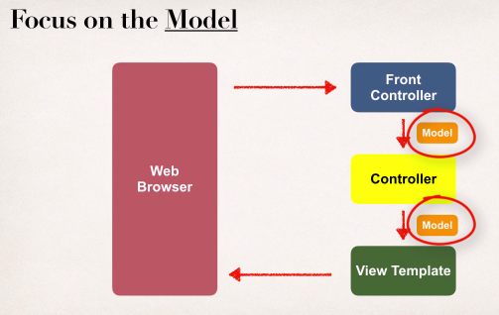

**Spring Model**:

1. The Model is a container for your application data
2. In our controller
   1. We can put anything in the model
   2. String, objects, info from database, etc. ….
3. Our view page (JSP) can access data from the **Model**

**Code Example**:

1. We want to create a new method to process form data
2. Read the form data: student’s name
3. Convert the name to upper case
4. Add the uppercase version to the model

**Passing Model to your Controller**:

@RequestMapping("/processFormVersionTwo")

**public** String letsShoutDude(HttpServletRequest request, Model model) {

// read the request parameter from the HTML form

String theName = request.getParameter("studentName");

// convert the data to all caps

theName = theName.toUpperCase();

// create the message

String result = "Yo! " + theName;

// add message to the model

model.addAttribute("message", result);

**return** "helloworld";

}

**View Template – JSP**:

<html><body>Hello World of Spring!...The message: ${message}</body></html>

3. Adding Data to the Spring Model - Overview